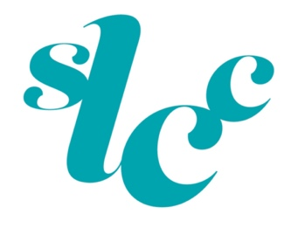
Counselling Charges and Cancellation Policy
An Initial Consultation can take up to 1½ hours at a cost of £135.00. We offer short-term and long-term counselling support either face-to-face or via Teams. Depending on your needs follow on sessions are 1 hour at a cost from £90.00 - £180.
We ask for at least 48 hours' notice for any cancellations. Missed appointments will be charged at the full rate £90.00.
We accept most health insurance providers.

